HDD to SSD Replacement Lab
Author: Rutva
Skill Area: IT Support / Computer Hardware Maintenance
Lab Source: JobSkillShare Virtual Lab
Lab Overview
This lab involved replacing a traditional Hard Disk Drive (HDD) with a Solid-State Drive (SSD) to improve system performance and storage reliability.
Objective
- Remove an existing HDD from a laptop.
- Install a higher-performance SSD.
- Verify successful installation.
- Demonstrate practical IT support hardware skills.
Business Scenario
A user required improved laptop performance and additional storage capacity. Instead of replacing the entire laptop, the existing HDD was upgraded to an SSD.
Benefits
- Faster boot times
- Improved application performance
- Better durability
- Lower power consumption

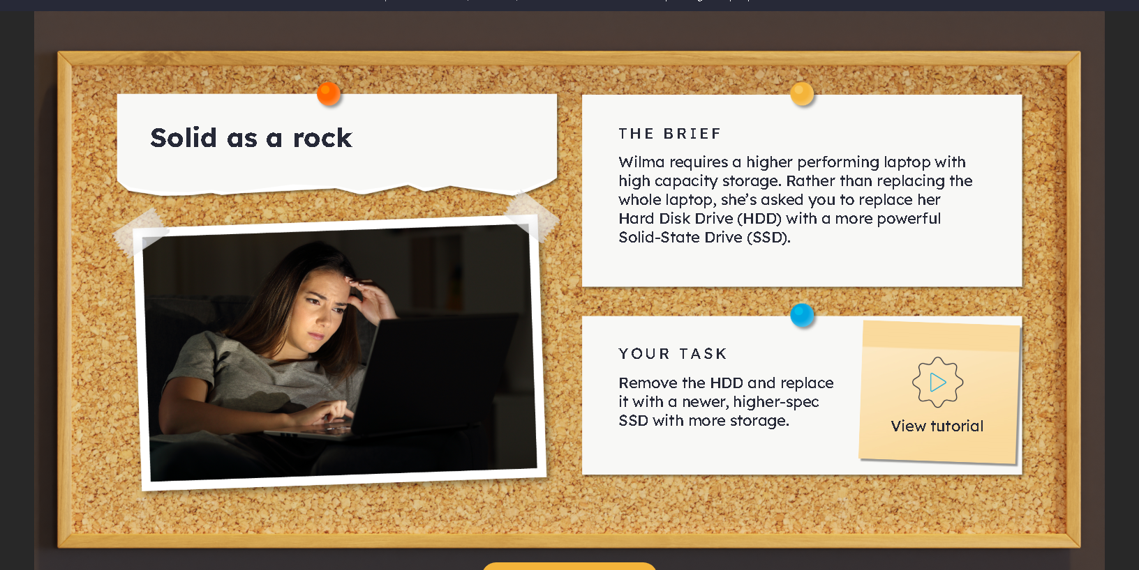

Procedure Performed
Step 1: Preparation
- Backed up important data.
- Ensured anti-static working conditions.
- Gathered necessary tools.
Step 2: Access Internal Components
- Opened laptop casing.
- Located existing HDD.
Step 3: Remove HDD
- Disconnected SATA connectors.
- Removed HDD mounting screws.
- Carefully removed HDD.
Step 4: Install SSD
- Inserted WD Blue SATA SSD.
- Connected SATA interface.
- Secured SSD into drive bay.
Step 5: Verification
- Reassembled laptop.
- Booted system.
- Verified SSD detection in BIOS.

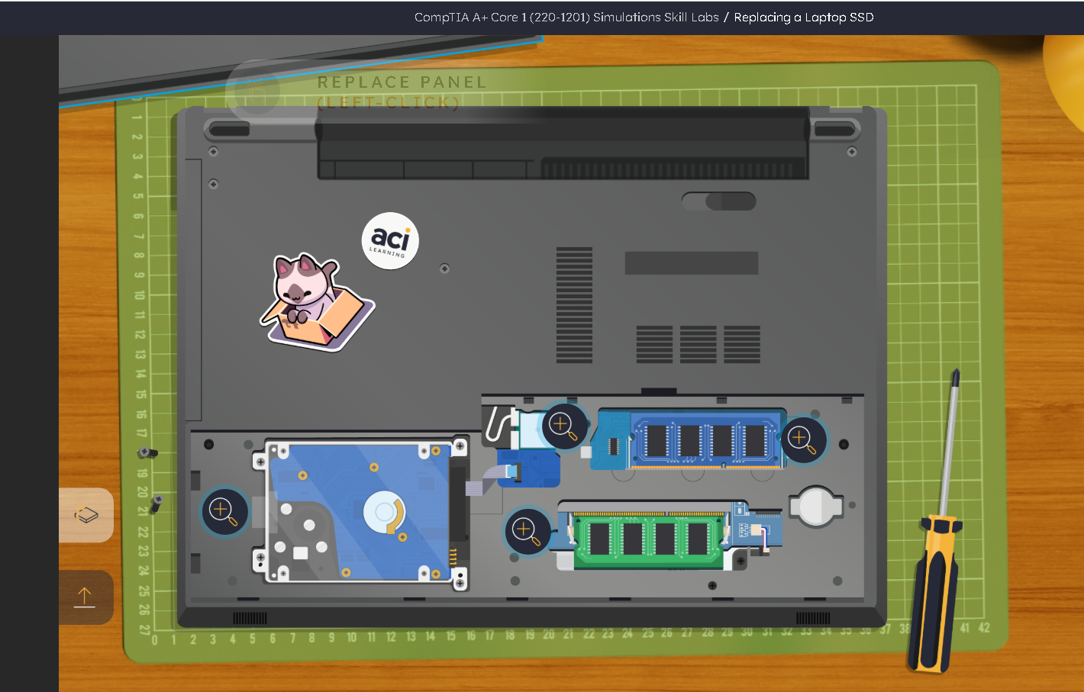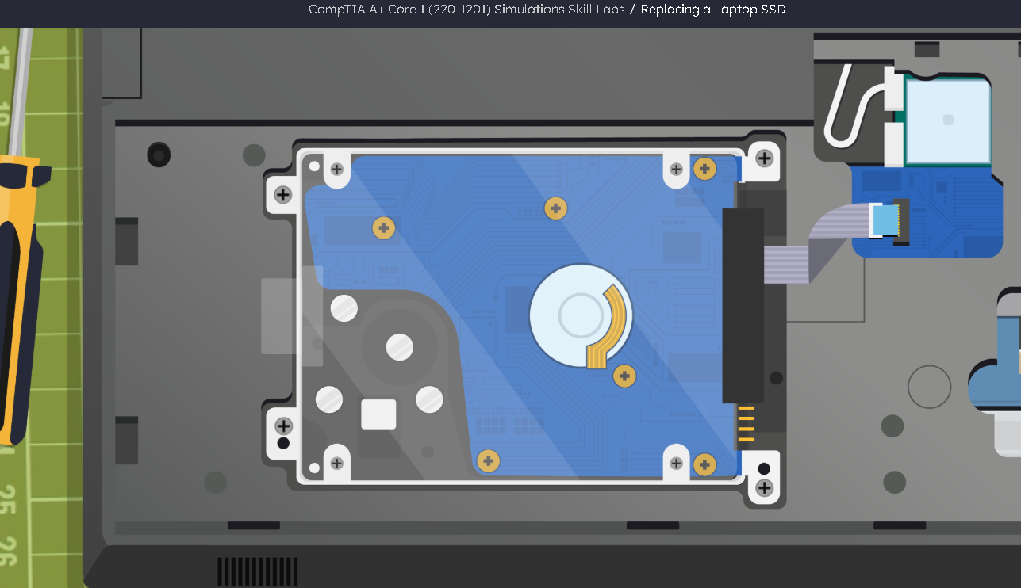

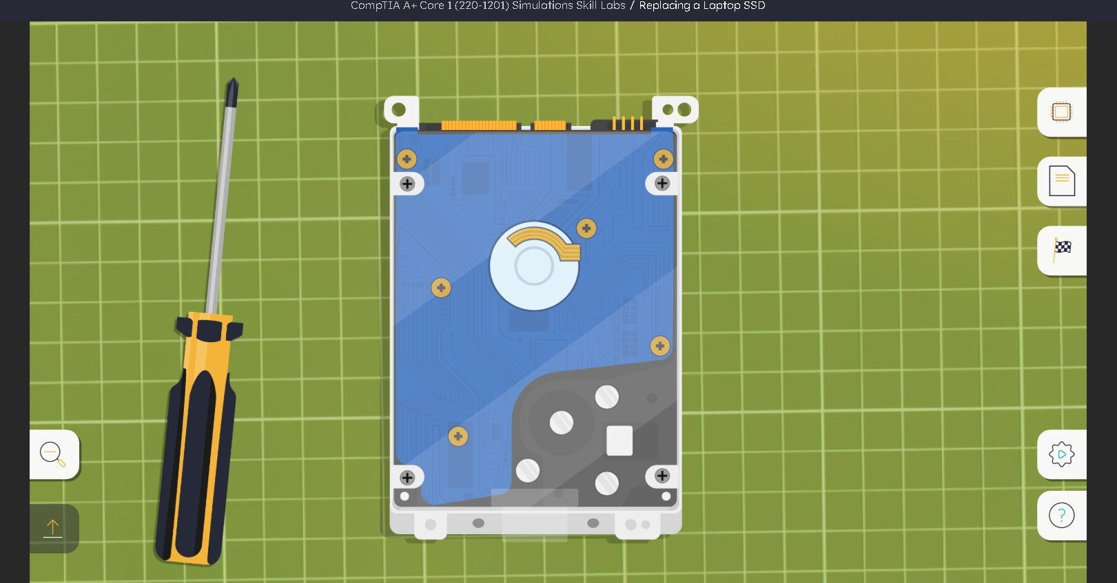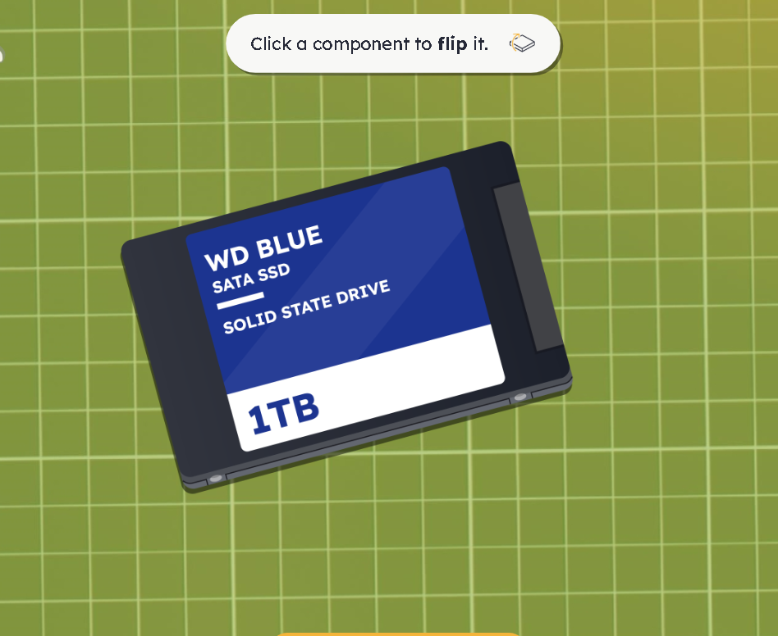

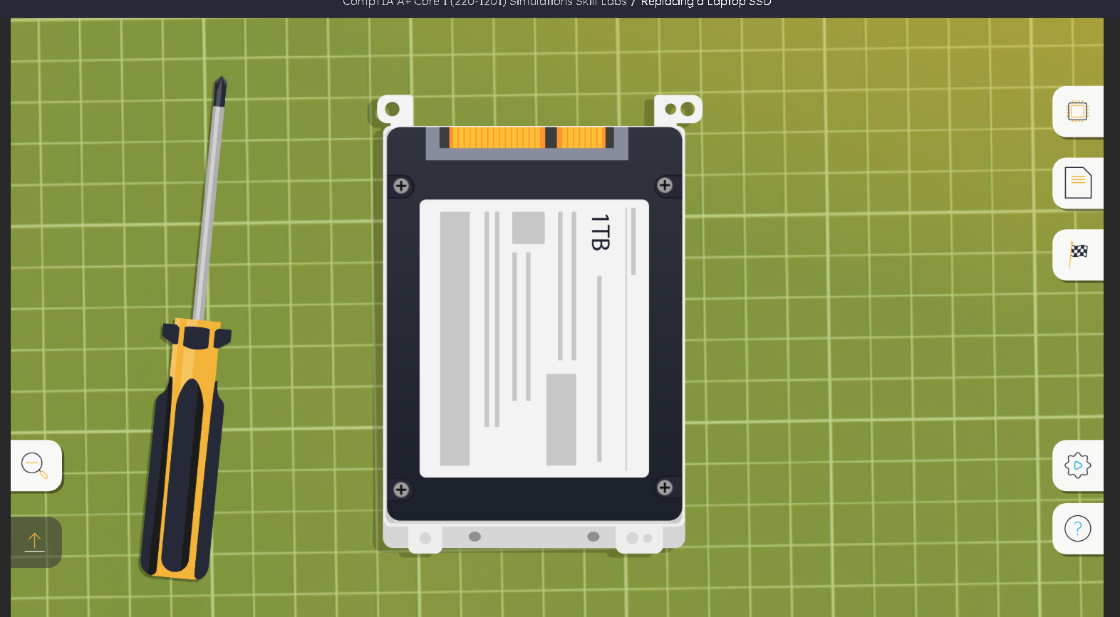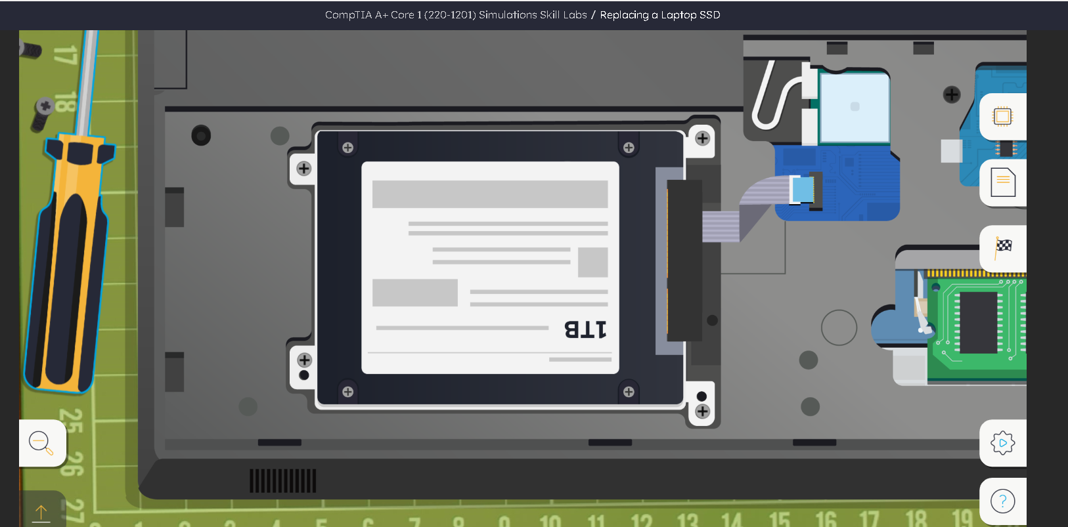
Best Practices Followed
- Data backup completed before upgrade
- SSD compatibility verified
- Proper tools used
- Anti-static precautions followed
- Hardware connections verified before power-on


